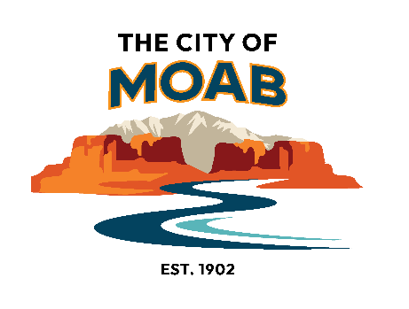

RAP Tax Grant Project Guidelines
Supporting and promoting recreational, cultural, arts and parks facilities and programs to benefit the Moab community

These funds are meant to aid project and program-based activities (art creation, art presentation, park and recreation facilities, capital projects, and recreation programs).

Capital projects are allowed but must be available for public use for at least 10 years. This timeframe may vary depending on project specifics including dollar amount, the estimated useful life of the capital project, etc. This timeframe will be determined before the grants are awarded.
Applicants are required to have 501(c)(3) status to qualify for a grant.
If an applicant (such as a local artist) does not have such status, they must partner with an organization that does to receive funding.

Additional Requirements:
- Projects must take place within Moab City limits.
- Projects must be completed within one year of the grant award.
- Projects must be matched by at least 25% (direct or indirect match)
- An entity may only apply for up to 20% of the total RAP Tax Grant funds available for the year. In 2026 the total available funding is $85,000 and the application limit amount is $17,000.
- Grant awards will be distributed as one payment to each accepted organization once the grant contract is completed.
- If the organization has a currently open RAP Tax project, they may apply for a new cycle of RAP Tax funding but will not be awarded funds until the open project is completed.
- Projects are required to announce and display that funding was provided by the City of Moab RAP Tax Program.

RAP/Tax funds may be USED for expenditures directly related to:
- Collections /Exhibits: Acquisitions or public display of items that in part, or as a whole, are collected or exhibited.
- Contracted Services: Services obtained through the aid or direction of a second individual or company. that are directly related to the project.
- Salaries that have a direct relation to the project (i.e. an art instructor’s time in preparing and teaching an art program)
- General administration and overhead costs may be allowed if the applicant can demonstrate a direct relation or need to the proposed project: These costs are limited to a maximum of 10% of the total requested amount.
- Marketing/Advertising: Promotion of the organization’s RAP Tax funded project/program
- Programs/Performance/Production: Staging of programs, performances, productions, cultural festivals
- Projects: Development of one-of-a-kind or one-time physical item or one-time event
- Travel/Housing: Travel by organization’s staff for specific projects/programs; travel and housing for performers
RAP/Tax funds may NOT BE USED for (this list is not exhaustive):
- Accumulated deficits or debt retirement
- Public schools and/or school programs or hiring of temporary or permanent staff
- Lobbying Expenses
- Scholarships, purchase awards or cash prizes
- Regular operations of Magazines or Newspapers
- Activities intended primarily for fundraising
- Rehabilitative or therapeutic programs
- Fireworks
- Rodeos
- Activities that are primarily religious in purpose
- Cash reserves

Projects will be evaluated on:

- Quality of Proposed Project
- Demonstrated Community Need
- Benefits to the Community
- The organization’s history and ability to implement the project, and financial considerations

Evaluation Criteria

Quality of proposed project
- The quality and clarity of the project goals and design
- Completeness
- Value of supporting materials

Demonstrated community need
- What is the current need of Moab citizens that this project aims to address?
- Are other projects or programs already addressing this need?

Benefits to the community
- The number of Moab residents by age, user group, etc., served by the project.
- Potential for the project to become an influential part of the Moab community experience in years to come.
- Tangible benefits to the Moab community.

The organization's history, ability to implement the project, and financial considerations
- The ability to carry out the project based on factors including the appropriateness of the budget, the resources involved, and the qualifications of the project’s personnel
- History of past City funding and RAP Tax projects

