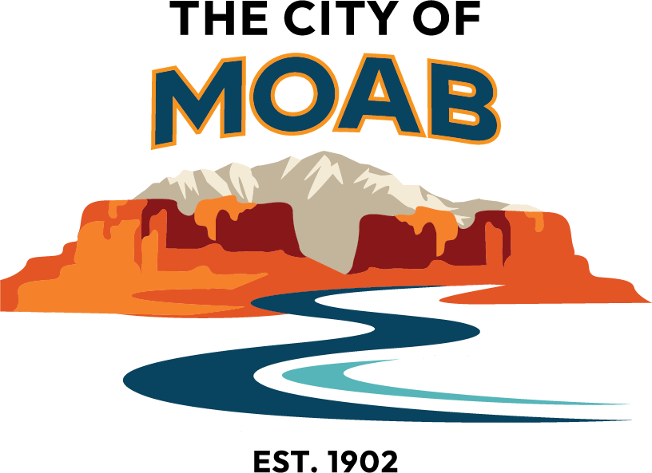

RAP Tax Funding Frequently Asked Questions

What is the RAP tax?
The Recreation Arts and Parks (RAP) tax is a sales and use tax the voters approved in 2020. The RAP tax is a 1/10 of 1% sales tax included on qualifying sales and uses within Moab City limits.

How can the RAP tax be used?
According to State Code, Recreation, Arts & Parks tax revenues can only be used for recreational, cultural, arts and parks facilities and programs provided by the city or qualifying nonprofit groups. State law prohibits the use of RAP Tax revenue for any other purpose, including general administrative expenses.

How is the Moab RAP Tax allocated?
80% of the revenue goes to City projects and 20% goes to community grants.
This allocation of City and community grants can be reviewed each year through the City’s budgeting process and may change.

How are the City funds used?
The City’s allocation will go to updating outdated park amenities, failing infrastructure, and providing new recreation, arts and parks opportunities. The prioritizing of projects will be refined through the Parks Master Plan and City Strategic Planning. Projects may be large in nature and require more than a one-year allocation.

How are the community grants distributed?
Eligible nonprofits will apply for projects through an annual grant cycle. The applications will be revised by the Recreation, Arts and Parks Tax Advisory Committee (RAP TAC), and the Committee will provide their recommendations to City Council for final approval.

What is the Recreation, Arts and Parks Tax Advisory Committee (RAP TAC)?
The RAP TAC is a five-member advisory committee appointed by the City Council. The committee representation must include one (1) member with demonstrated knowledge of/or experience in the arts, one (1) member with demonstrated knowledge of or experience in parks and recreation, and (3) members at large. The purpose of the RAP Tax Advisory Committee is to receive applications from groups that qualify to receive RAP Tax funds, review the applications, and recommend allocation of the RAP Tax revenue to the Moab City Council.

Who is eligible to apply for RAP Tax Grants?
Applicants must be a local 501(c)(3) nonprofit organization, or an applicant must partner with a 501(c)(3) nonprofit. All projects or programs must be related to recreation, arts, or parks and take place within Moab city limits. For full eligibility requirements visit www.moabcity.org/RAP.

What does partnering with a 501(c)(3) nonprofit entail?
If you or your organization are not already a qualified 501(c)(3) entity, you must find a 501(c)(3) to partner with. Partnerships in this capacity are loosely defined, and generally the non-profit must provide some support or oversight of the project, but do not need to provide any specific financial assistance.

When are applications due?
Applications are due February 27, 2026, by 5:00 p.m.

What is the available funding amount for applications in 2025?
Funding available in the 2026 application cycle is $85,000. An entity may only apply for up to 20% of the total RAP Tax Grant funds available for the year, the project application limit is $17,000.

Where do I go for more information?
Visit the website: www.moabcity.org/RAP. Email RAPTAC@moabcity.gov, or call Kelley McInerney at 435-259- 6272, ext. 672.

